**create table employees(**

**employee_id number primary key,**

**first_name varchar2(20) default null,**

**last_name varchar2(25) not null,**

**email varchar2(25) not null,**

**phone_number varchar2(20) default null,**

**hire_date date not null,**

**job_id varchar2(10),**

**salary number default null,**

**commission_pct number default null,**

**manager_id number default null,**

**department_id number**

**);**

**\**

**create table region(**

**region_id number primary key,**

**region_name varchar2(25)**

**);**

**create table countries(**

**country_id char(2) primary key,**

**country_name varchar2(40),**

**region_id number references region(region_id)**

**);**

**create table countries(**

**country_id char(2) primary key,**

**country_name varchar2(40),**

**region_id number references region(region_id)**

**);**

**create table location**

**(**

**Location_id number primary key,**

**Street_address varchar2(25),**

**Postal_code varchar2(12),**

**City varchar2(30),**

**State_province varchar2(12),**

**Country_id char(2) references countries(country_id)**

**);**

**create table department**

**(**

**Department_id number primary key,**

**Department_name varchar2(30),**

**Manager_id number,**

**Location_id number references location(Location_id)**

**);**

**create table jobs**

**(**

**Job_id varchar2(10) primary key,**

**Job_tile varchar2(35),**

**Min_salary number,**

**Max_salary number**

**);**

**INSERT INTO EMPLOYEES VALUES (100,'Steven','King','Sking','515.123.4567','17-JUN-03','AD_PRES',24000,0,0,90)**

**INSERT INTO EMPLOYEES VALUES (101,'Neena','Kochhar','Nkochhar','515.123.4568','21-SEP-05','AD_VP',17000,0,100,90)**

**INSERT INTO EMPLOYEES VALUES (102,'Lex','De Haan','Ldehaan','515.123.4569','13-JAN-01','AD_VP',17000,0,100,90)**

**INSERT INTO EMPLOYEES VALUES (103,'Alexander','Hunold','Ahunold','590.423.4567','13-JAN-06','IT_PROG',9000,0,102,60)**

**INSERT INTO EMPLOYEES VALUES (104,'Bruce','Ernst','Bernst','590.423.4568','21-MAY-07','IT_PROG',6000,0,103,60)**

**INSERT INTO EMPLOYEES VALUES (105,'David','Austin','Daustin','590.423.4569','25-JUN-05','IT_PROG',4800,0,103,60)**

**INSERT INTO EMPLOYEES VALUES (106,'Valli','Pataballa','Vpatabal','590.423.4560','05-FEB-06','IT_PROG',4800,0,103,60)**

**INSERT INTO EMPLOYEES VALUES (107,'Diana','Lorentz','Dlorentz','590.423.5567','07-FEB-07','IT_PROG',4200,0,103,60)**

**INSERT INTO EMPLOYEES VALUES (108,'Nancy','Greenberg','Ngreenbe','515.124.4569','17-AUG-02','FI_MGR',12000,0,101,100)**

**INSERT INTO EMPLOYEES VALUES (109,'Daniel','Faviet','Dfaviet','515.124.4169','16-AUG-02','FI_ACCOUNT',9000,0,108,100)**

**QUERY3:**

**SELECT*FROM EMPLOYEES**

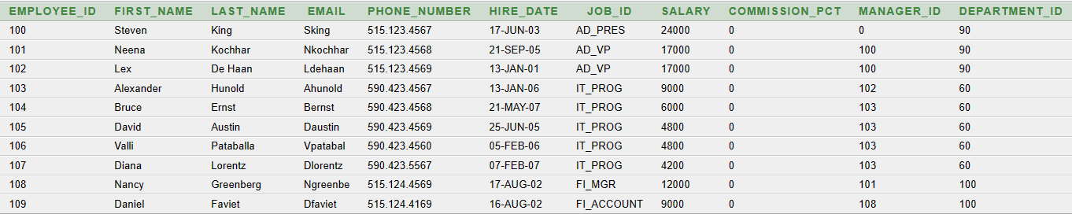

**QUERY4:**

**SELECT FIRST_NAME, LAST_NAME, JOB_ID, SALARY FROM EMPLOYEES**

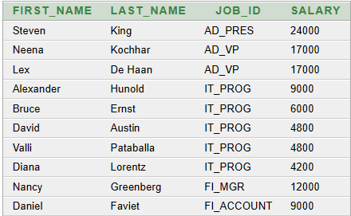

**QUERY5:**

**TRUNCATE TABLE EMPLOYEES**

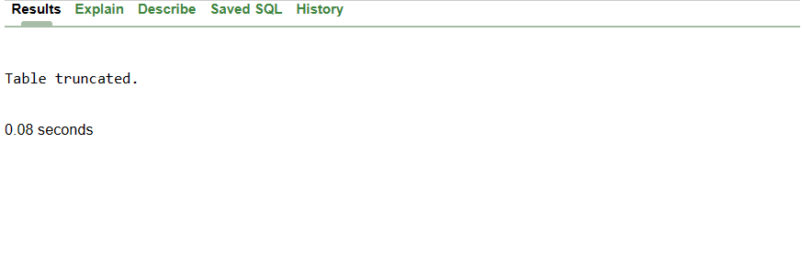

**QUERY6:**

**DROP TABLE EMPLOYEES**

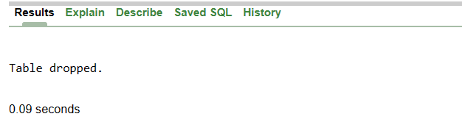

**QUERY9:**

**SELECT FIRST_NAME||'_'||LAST_NAME as full_name ,JOB_ID,SALARY*12 as annual_salary from EMPLOYEES ;**

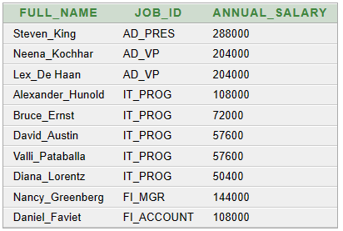

**QUERY10:**

**SELECT COUNT(EMPLOYEE_ID) as Total_number_of_Employees from EMPLOYEES**



**QUERY11:**

**SELECT SUM(SALARY) as Total_Annual_Salary from EMPLOYEES;**

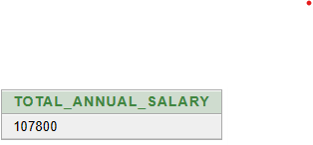

**QUERY12:**

**SELECT max(SALARY) from EMPLOYEES; #Max Salary**

**SELECT min(SALARY) from EMPLOYEES; #Min Salary**





**QUERY13:**

**SELECT FIRST_NAME||'_'||LAST_NAME as full_name,SALARY from EMPLOYEES ORDER BY SALARY ;**

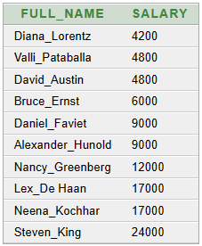

**QUERY14:**

**SELECT FIRST_NAME||'_'||LAST_NAME as full_name,SALARY from EMPLOYEES ORDER BY SALARY desc;**



**QUERY15:**

**SELECT FIRST_NAME||'_'||LAST_NAME as full_name from EMPLOYEES ORDER BY full_name;**

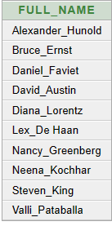

**(16) error :(**

**SELECT EMPLOYEE_ID,FIRST_NAME||'_'||LAST_NAME as FULL_NAME,DEPARTMENT_ID,SALARY from EMPLOYEES ORDER BY FULL_NAME ,DISTINCT DEPARTMENT_ID, ORDER BY SALARY desc;**

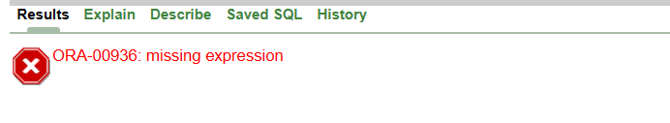

**SELECT EMPLOYEE_ID,FIRST_NAME||'_'||LAST_NAME as FULL_NAME,DEPARTMENT_ID,SALARY from EMPLOYEES ORDER BY FULL_NAME , ORDER BY SALARY desc , DISTINCT DEPARTMENT_ID ;**



**SELECT EMPLOYEE_ID,FIRST_NAME||'_'||LAST_NAME as FULL_NAME,DEPARTMENT_ID,SALARY, DISTINCT( FULL_NAME) DEPARTMENT_ID from EMPLOYEES group by DEPARTMENT_ID ,ORDER BY FULL_NAME ASC,SALARY desc , DEPARTMENT_ID ASC ;**



**(17)SELECT FIRST_NAME||'_'||LAST_NAME as full_name ,SALARY*12 as annual_salary from EMPLOYEES order by annual_salary desc;**

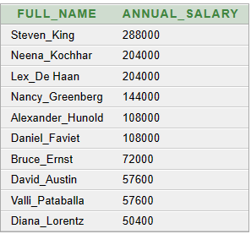

**(18)SELECT count(EMPLOYEE_ID),DEPARTMENT_ID**

**from EMPLOYEES**

**group by DEPARTMENT_ID**

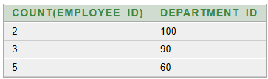

**(19)SELECT count(EMPLOYEE_ID),JOB_ID**

**from EMPLOYEES**

**group by JOB_ID**

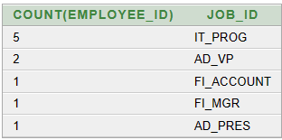

**(20)SELECT sum(salary),DEPARTMENT_ID**

**from EMPLOYEES**

**group by DEPARTMENT_ID**

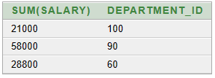

**(21)SELECT max(SALARY),DEPARTMENT_ID**

**from EMPLOYEES**

**group by DEPARTMENT_ID**

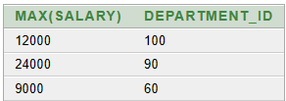

**(22)SELECT JOB_ID,sum(SALARY) as Total_Salary**

**from EMPLOYEES**

**group by JOB_ID**

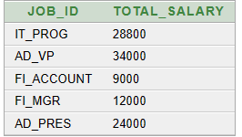

**SELECT CONCAT(FIRST_NAME,LAST_NAME) from EMPLOYEES;**

**update employees72 set COMMISSION_PCT=COMMISSION_PCT+SALARY*5/100;**

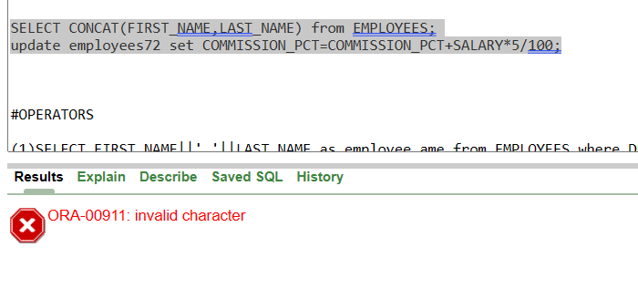

**#OPERATORS**

**(1)SELECT FIRST_NAME||' '||LAST_NAME as employee_ame from EMPLOYEES where DEPARTMENT_ID=20**

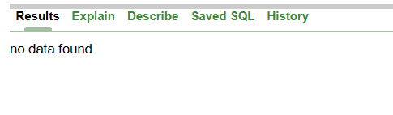

**(2)SELECT FIRST_NAME||' '||LAST_NAME as employee_name , SALARY*12 as annual_salary from EMPLOYEES where SALARY >10000**

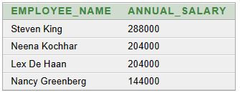

**(3)SELECT FIRST_NAME||' '||LAST_NAME as employee_name , SALARY/30 as daily_salary from EMPLOYEES where SALARY>100**

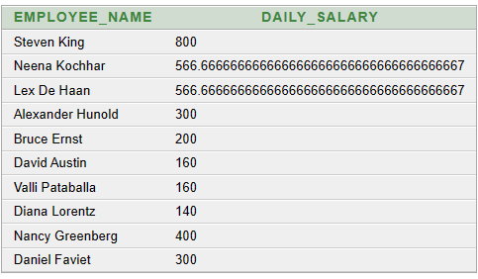

**(4)SELECT FIRST_NAME||' '||LAST_NAME as employee_name from EMPLOYEES where DEPARTMENT_ID!=20**

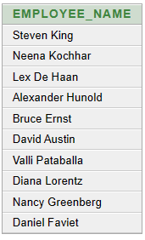

**(5)SELECT FIRST_NAME||' '||LAST_NAME as employee_name,JOB_ID from EMPLOYEES where JOB_ID='AC_MGR' and SALARY <5000 error**



**(6)SELECT FIRST_NAME||' '||LAST_NAME as employee_name,JOB_ID,SALARY from EMPLOYEES where job_id='FI_ACCOUNT' and SALARY<20000**



**(7)SELECT FIRST_NAME||' '||LAST_NAME as employee_name,JOB_ID,SALARY from EMPLOYEES where job_id='FI_ACCOUNT' and SALARY between 5000 and 20000**



**(8)SELECT FIRST_NAME||' '||LAST_NAME as employee_name,SALARY from EMPLOYEES where COMMISSION_PCT!=0**



**(9)SELECT FIRST_NAME||' '||LAST_NAME as employee_name,SALARY from EMPLOYEES**

**WHERE FIRST_NAME IN ('John', 'Jane', 'Peter', 'David');**



**(10)SELECT FIRST_NAME||' '||LAST_NAME as employee_name,JOB_ID,SALARY from EMPLOYEES**

**WHERE JOB_ID NOT IN ('PRESIDENT', 'MGR')**

**ORDER BY salary ASC;**



**(11)SELECT FIRST_NAME || ' ' || LAST_NAME AS eployee_name, hire_date**

**FROM EMPLOYEES**

**WHERE hire_date < '1-JAN-2005' OR hire_date > '31-DEC-2005';**

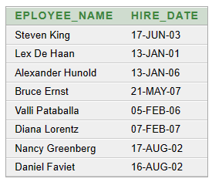

**(12)SELECT FIRST_NAME || ' ' || LAST_NAME AS eployee_name, hire_date**

**FROM EMPLOYEES**

**WHERE hire_date IN('1-JUL-2006','24-MAR-2007','04-JAN-2008')**

**ORDER BY HIRE_DATE ASC;**



**(13)SELECT FIRST_NAME || ' ' || LAST_NAME||', '||JOB_ID AS eployee_detail**

**FROM EMPLOYEES**

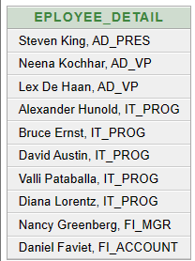

**(14)SELECT FIRST_NAME || ' ' || LAST_NAME AS employee_detail**

**FROM EMPLOYEES where hire_date between '1-JAN-2004'AND'31-DEC-2008'**

